**Facebook Watch**

The below steps explains the development setup and usage of facebook watch application.

1. Download rails, ruby and redis server.
2. After pulling code from github, run following commands for downloading dependencies from location of Gemfile (Application root)
   1. Command – bundle install
   2. Command – bundle update
3. Run the following commands to setup the database from application root directory
   1. Command – rake db:create
   2. Command – rake db:migrate
4. Command to start application server - rails server
5. Command for starting redis

**Option 1:**

launchctl load ~/Library/LaunchAgents/homebrew.mxcl.redis.plist

To install redis - <https://medium.com/@petehouston/install-and-config-redis-on-mac-os-x-via-homebrew-eb8df9a4f298#.wpnjsiv5u>

**Option 2:** redis-server

1. Launch a browser and navigate to the URL - <http://localhost:3000/>
2. Change the app secret, app id in the application and file omniauth.
3. To add resources, find the facebook page, find the facebook number ID - <http://www.findmyfbid.com/> using facebook url of group or user.
4. Facebook API explorer - <https://developers.facebook.com/tools/explorer/>

Same can be performed in APItest in FBWatch

1. To get page posts, use facebook API - https://developers.facebook.com/tools/explorer/145634995501895/?method=GET&path=952571668097034%2Ffeed&version=v2.8

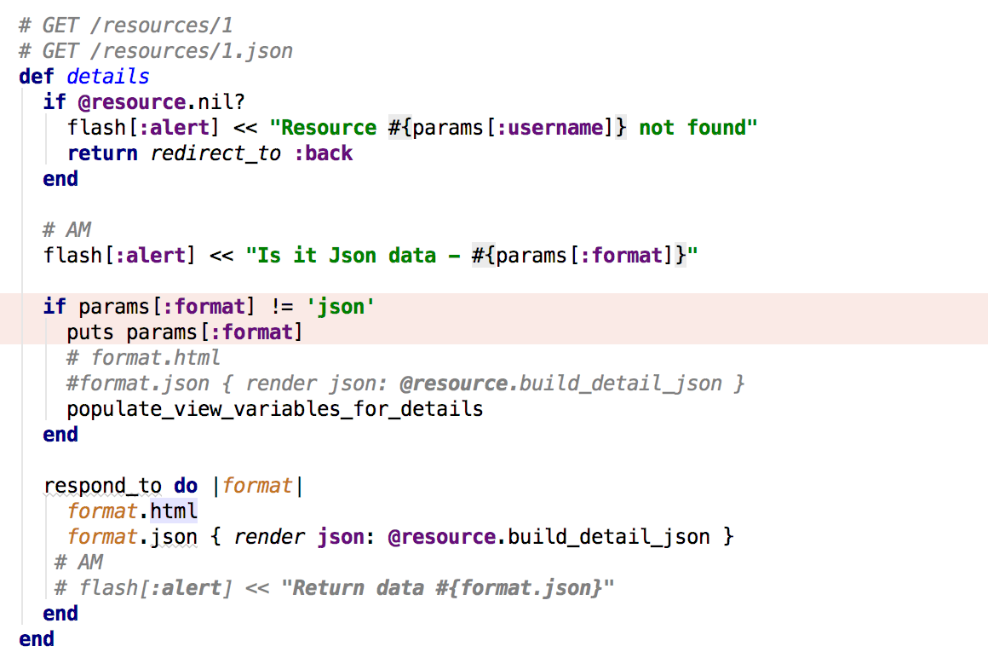

1. After setting up everything, feeds from facebook should look like below

